THEMENBLOCK 6: Growing Up & Emotions

CATEGORY A: CONTRASTING IMAGES

TASK SET A1: Expressing Emotions

Part 1 — Individual Long Turn

Task
Give a five-minute talk on emotional expression and mental health in which you
- describe, compare and contrast the two pictures above.
- discuss why young people hide their feelings and evaluate the consequences.
- comment on emotional authenticity and suggest ways to create safe spaces.

Part 2 — Paired Activity
Task
Your school wants to launch a mental health awareness campaign called "It's Okay Not to Be Okay." You and your partner are on the planning committee.
Discuss the following ideas and agree on THREE to include:
- Creating anonymous 'feeling walls' where students can post their emotions
- Training peer supporters to listen without judgment
- Hosting a speaker series with young adults sharing mental health stories
- Developing social media content that normalizes emotional struggles
- Organizing 'mental health days' with relaxation activities and workshops

TASK SET A2: Fitting In vs. Standing Out

Part 1 — Individual Long Turn
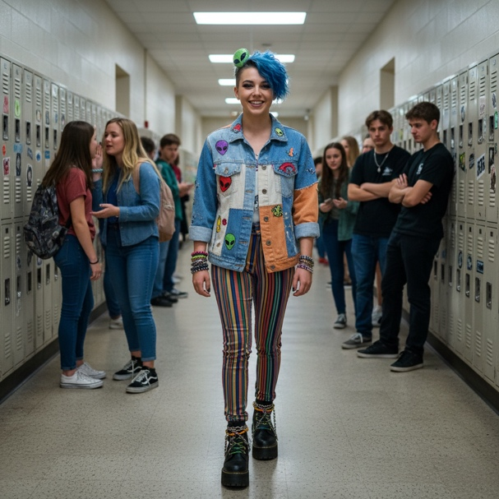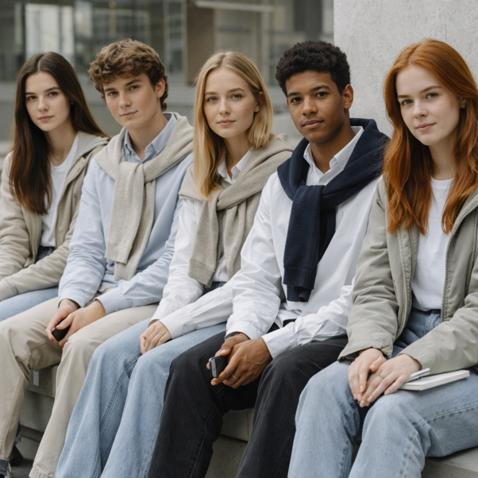
Task
Give a five-minute talk on peer pressure and individuality in which you
- describe, compare and contrast the two pictures above.
- discuss the pros and cons of conformity versus individuality for teenagers.
- comment on peer pressure in the digital age and outline strategies for authenticity.

Part 2 — Paired Activity
Task
Your school is organizing a "Be Yourself Week" to encourage students to express their individuality. You and a partner are helping to plan the program.
Discuss the following activities and agree on THREE to include:
- "Unplug and Connect" day – no phones allowed, focus on face-to-face conversations
- Personal style showcase – students dress to express their unique identities
- Talent spotlight – platform for hidden talents (music, art, coding, etc.)
- Storytelling circles – small groups share personal experiences and perspectives
- "Different is Cool" poster campaign designed by students

TASK SET A3: Learning to Let Go

Part 1 — Individual Long Turn
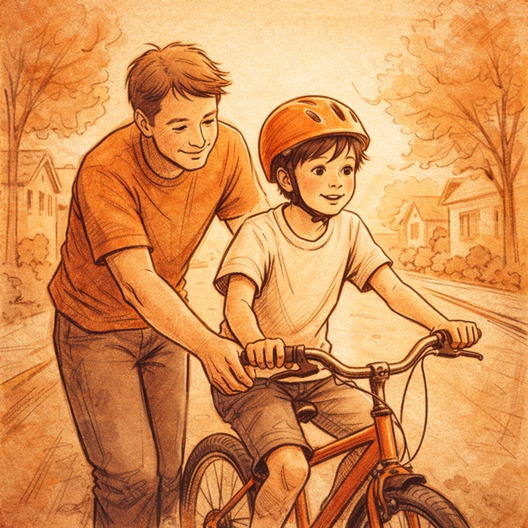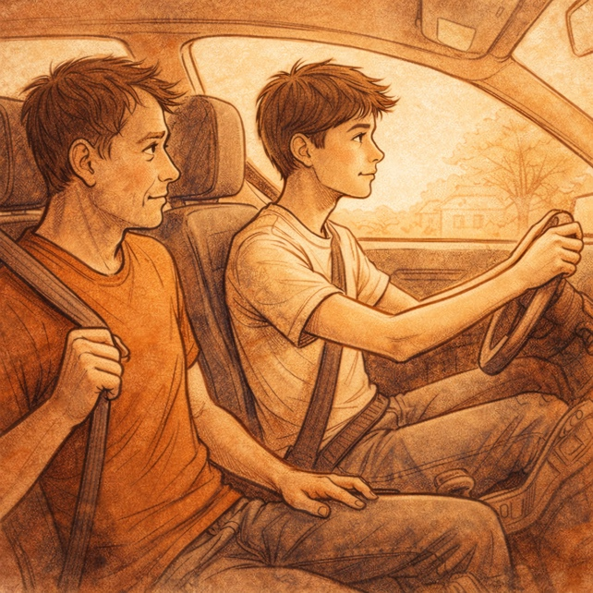
Task
Give a five-minute talk on growing independence in adolescence in which you
- describe, compare and contrast the two pictures above.
- discuss challenges for teenagers and parents during this transition.
- comment on your experience gaining independence and speculate on future milestones.

Part 2 — Paired Activity
Task
Your class has been invited to meet with the school counselor to discuss how the school can better support students during major life transitions.
Before the meeting, discuss the following topics and agree on THREE to prioritize:
- How can schools help students prepare for life after graduation (university, work, gap year)?
- What support do students need when family situations change (divorce, moving, loss)?
- How should schools address the pressure students feel about their future?
- What role should schools play in teaching practical life skills (finances, cooking, etc.)?
- How can schools help students who struggle with the transition from childhood to adolescence?

CATEGORY B: QUOTES

TASK SET B1: The Emotional Storm
PART 1 — Individual Long Turn
Quotes:
Quote 1:
"Adolescence represents an inner emotional upheaval, a struggle between the eternal human wish to cling to the past and the equally powerful wish to get on with the future."
— Louise J. Kaplan, Adolescence: The Farewell to Childhood (1984)
Quote 2:
"Adolescence is when the very worst and best impulses in the human soul struggle against each other for possession."
— G. Stanley Hall, Adolescence: Its Psychology (1904)
Task:
Give a five-minute talk on emotional development during adolescence in which you
- critically analyze both quotes and discuss what they suggest about adolescent emotions.
- evaluate whether the 'upheaval' described is inevitable or depends on circumstances.
- comment on your emotional journey and outline what helps teenagers navigate this period.

Part 2 — Paired Activity

Task
Your class is creating a "Teen Survival Guide" with advice from students for students.
Discuss the following coping strategies and agree on THREE to feature in the guide:
- Journaling or creative expression (art, music, writing)
- Physical activity and sports
- Talking to trusted friends or family members
- Mindfulness and relaxation techniques
- Setting boundaries with social media and screens

TASK SET B2: Understanding Your Emotions
PART 1 — Individual Long Turn
Quotes:
Quote 1:
"Mental health is not about feeling good. Instead, it's about having the right feelings at the right time and being able to manage those feelings effectively."
— Lisa Damour, Ph.D., The Emotional Lives of Teenagers (2023)
Quote 2:
"When teenagers understand what they are feeling and why, they suddenly have choices that were not available to them before."
— Lisa Damour, Ph.D., The Emotional Lives of Teenagers (2023)
Task:
Give a five-minute talk on emotional intelligence in adolescence in which you
- analyze both quotes and discuss how they challenge assumptions about mental health.
- evaluate the claim that understanding emotions gives teenagers 'choices.'
- comment on how schools and families could help develop emotional intelligence.

Part 2 — Paired Activity

Task
Your school wants to add a "Self-Reflection" component to its wellbeing program.
Discuss the following questions for a student self-reflection journal and agree on THREE to prioritize:
- What triggered my strongest emotions this week, and how did I respond?
- When did I feel most like myself, and when did I feel pressure to be someone else?
- What relationships energize me, and which ones drain me?
- What am I avoiding, and why might that be?
- What would I tell my younger self about handling difficult emotions?

CATEGORY C: ALTERNATIVE PROMPTS

TASK SET C1: The Teen Mental Health Picture

Part 1 — Individual Long Turn

Text Extract

According to the World Health Organization (2024), one in seven adolescents aged 10-19 experiences a mental health condition. Anxiety and depression together account for approximately 40% of all mental health disorders in this age group, with anxiety affecting 5.3% and depression affecting 3.4% of 15-19 year-olds globally. Perhaps most concerning, suicide is now the third leading cause of death among young people aged 15-29. Despite this growing need, mental health services for young people remain inadequate or inaccessible in many countries.
— Source: WHO Fact Sheet: Adolescent Mental Health, September 2024
Task:
Give a five-minute talk on adolescent mental health in which you
- analyze the statistics and explain their significance for young people's wellbeing.
- discuss possible causes of rising mental health concerns among teenagers.
- comment on actions schools, governments, and communities should take.

Part 2 — Paired Activity
Task
You are working with a school psychologist to develop a mental health support program for your school.
Discuss the following aspects and agree on THREE to prioritize:
- Creating a peer mentoring system where trained older students support younger ones
- Establishing regular 'check-in' sessions with a counselor for all students
- Training teachers to recognize signs of mental health struggles
- Developing an anonymous reporting system for students in crisis
- Building partnerships with local mental health organizations for referrals

TASK SET C2: Teens, Screens, and Wellbeing

Part 1 — Individual Long Turn

ADOLESCENT WELLBEING TRENDS: 2018 vs. 2022
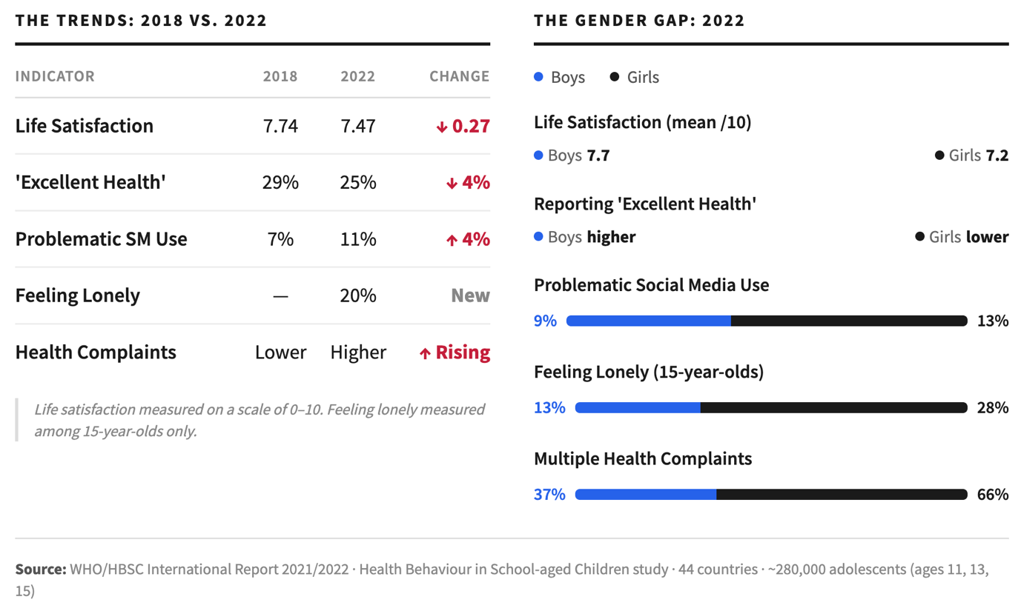
Task:
Give a five-minute talk on adolescent wellbeing and screen use in which you
- analyze the data and discuss the most concerning trends.
- evaluate the connection between social media use and declining wellbeing.
- comment on gender differences in the data and suggest explanations.

Part 2 — Paired Activity (Debate)
Task
Your school is holding a debate on the motion: "Social media does more harm than good for teenagers."
Take turns arguing for and against the motion, then try to reach a balanced conclusion. Consider:
- Impact on self-esteem and body image
- Connection and community vs. isolation
- Access to information and support resources
- Cyberbullying and online harassment
- Effect on sleep, attention, and academic performance

